**Skill:-ASP.NET Core 8.0 Web API**

**Filename:-6. WebApi_Handson**

**Document-6**

**Name:- 1. Create a Chat Application which uses Kafka as a streaming platform and consume the chat messages in the command prompt.**

**Solution:-**

***Created a* ***Console App (.NET Core) with .NET 8.0 named as*** *KafkaConsoleChat***

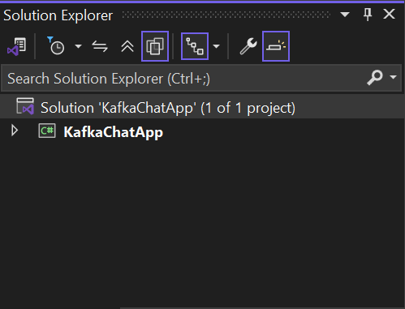

***Installed Kafka Plugin that is Confluent.Kafka in Project using Terminal***

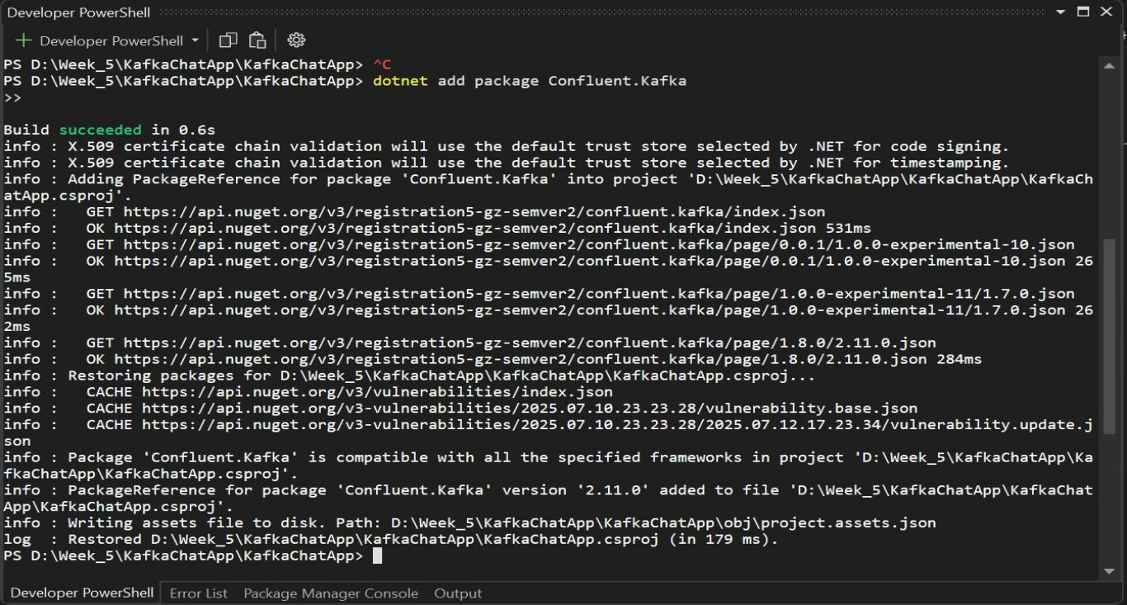

**Created a class Name as Producer.cs**

***Code for Producer.cs in KafkaConsoleChat***

using Confluent.Kafka;

using System;

using System.Threading.Tasks;

class Producer

{

public static async Task Start()

{

var config = new ProducerConfig

{

BootstrapServers = "localhost:9092"

};

using var producer = new ProducerBuilder<Null, string>(config).Build();

Console.WriteLine("Chat Producer. Type 'exit' to stop.");

while (true)

{

string msg = Console.ReadLine();

if (msg == "exit") break;

await producer.ProduceAsync("chat-topic", new Message<Null, string> { Value = msg });

Console.WriteLine("Sent: " + msg);

}

}

}

**Created a class Name as Consumer.cs**

***Code for Consumer.cs in KafkaConsoleChat***

using Confluent.Kafka;

using System;

class Consumer

{

public static void Start()

{

var config = new ConsumerConfig

{

BootstrapServers = "localhost:9092",

GroupId = "chat-group",

AutoOffsetReset = AutoOffsetReset.Earliest

};

using var consumer = new ConsumerBuilder<Ignore, string>(config).Build();

consumer.Subscribe("chat-topic");

Console.WriteLine("Chat Consumer Listening...");

while (true)

{

var cr = consumer.Consume();

Console.WriteLine("Received: " + cr.Message.Value);

}

}

}

***Code for Program.cs***

using System;

using System.Threading.Tasks;

class Program

{

static async Task Main(string[] args)

{

Console.WriteLine("1. Send Message");

Console.WriteLine("2. Receive Message");

Console.Write("Choose Option: ");

string input = Console.ReadLine();

if (input == "1")

await Producer.Start();

else

Consumer.Start();

}

}

***Now Running the Chat Console App***

***One as Producer***

***OutPut of Terminal to Send Message***

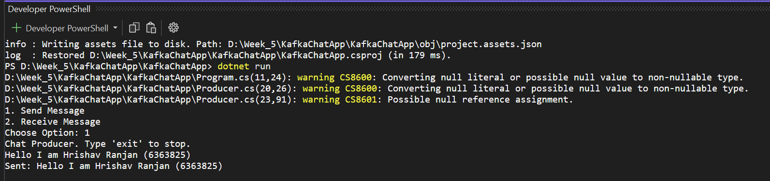

***Another one as consumer***

***OutPut of Terminal to Received the Message***

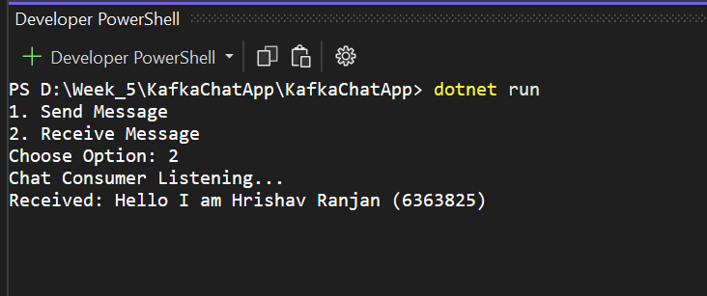

**Name:- 2.** Create a Chat Application using C# Windows Application using Kafka and consume the message in different client applications.

**Solution:-**

***Created a Windows Forms App (.NET Core)* ***with .NET 8.0 named as*** *KafkaWinFormsChat***

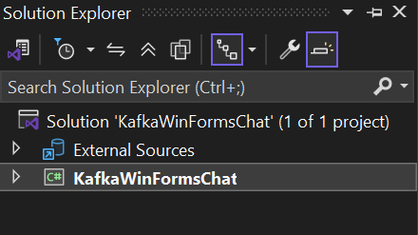

***Installed Kafka Plugin that is Confluent.Kafka in Project using Terminal***

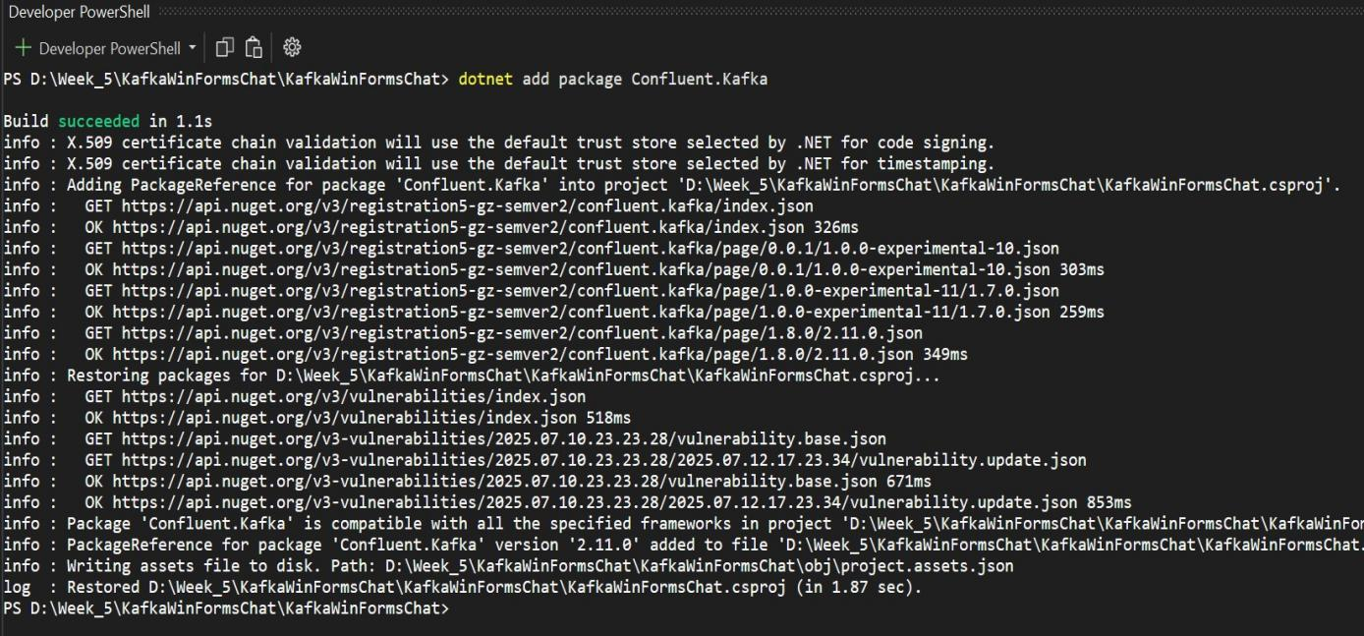

***Now we have designed the form with TextBox named as txtMessage,Button named as btnSend (Text name as Send),ListBox named as lstMessages all others Text name should be empty.***

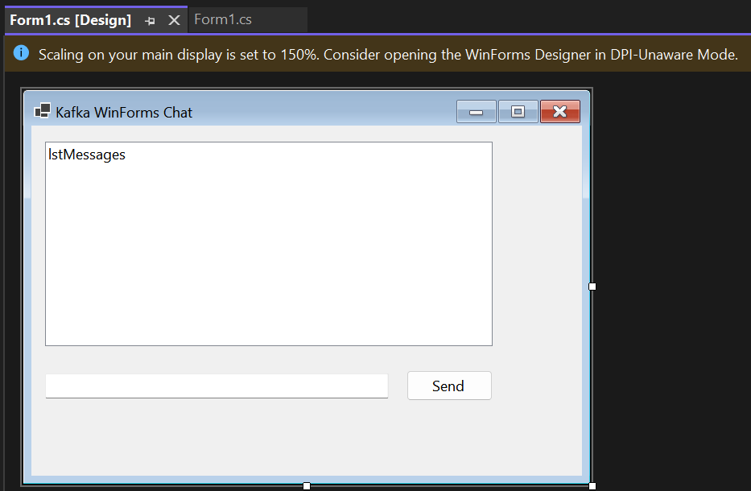

***We have design this from Toolbox***

***Code For Form.cs in KafkaWinFormsChat***

using Confluent.Kafka;

using System;

using System.Windows.Forms;

using System.Threading.Tasks;

using System.Threading;

namespace KafkaWinFormsChat

{

public partial class Form1 : Form

{

private IProducer<Null, string> producer;

private CancellationTokenSource cts;

public Form1()

{

InitializeComponent();

var config = new ProducerConfig { BootstrapServers = "localhost:9092" };

producer = new ProducerBuilder<Null, string>(config).Build();

cts = new CancellationTokenSource();

Task.Run(() => StartConsumer(cts.Token));

}

private async void btnSend_Click(object sender, EventArgs e)

{

var msg = txtMessage.Text.Trim();

if (string.IsNullOrEmpty(msg)) return;

await producer.ProduceAsync("chat-topic", new Message<Null, string> { Value = msg });

lstMessages.Items.Add("You: " + msg);

txtMessage.Clear();

}

private void StartConsumer(CancellationToken token)

{

var config = new ConsumerConfig

{

BootstrapServers = "localhost:9092",

GroupId = "winforms-group",

AutoOffsetReset = AutoOffsetReset.Earliest

};

using var consumer = new ConsumerBuilder<Ignore, string>(config).Build();

consumer.Subscribe("chat-topic");

try

{

while (!token.IsCancellationRequested)

{

var cr = consumer.Consume(token);

Invoke(new Action(() =>

{

lstMessages.Items.Add("Friend: " + cr.Message.Value);

}));

}

}

catch (OperationCanceledException)

{

consumer.Close();

}

}

protected override void OnFormClosing(FormClosingEventArgs e)

{

base.OnFormClosing(e);

cts.Cancel();

}

}

}

***We have already runed the Kafka in Terminals that is For Terminal 1 Zookeeper and Terminal 2 Kafka Server***

**Command for the Zookeeper**

cd C:\kafka

.\bin\windows\zookeeper-server-start.bat .\config\zookeeper.properties

**Command for the Kafka Server**

cd C:\kafka

.\bin\windows\kafka-server-start.bat .\config\server.properties

***Now Build the App by F5***

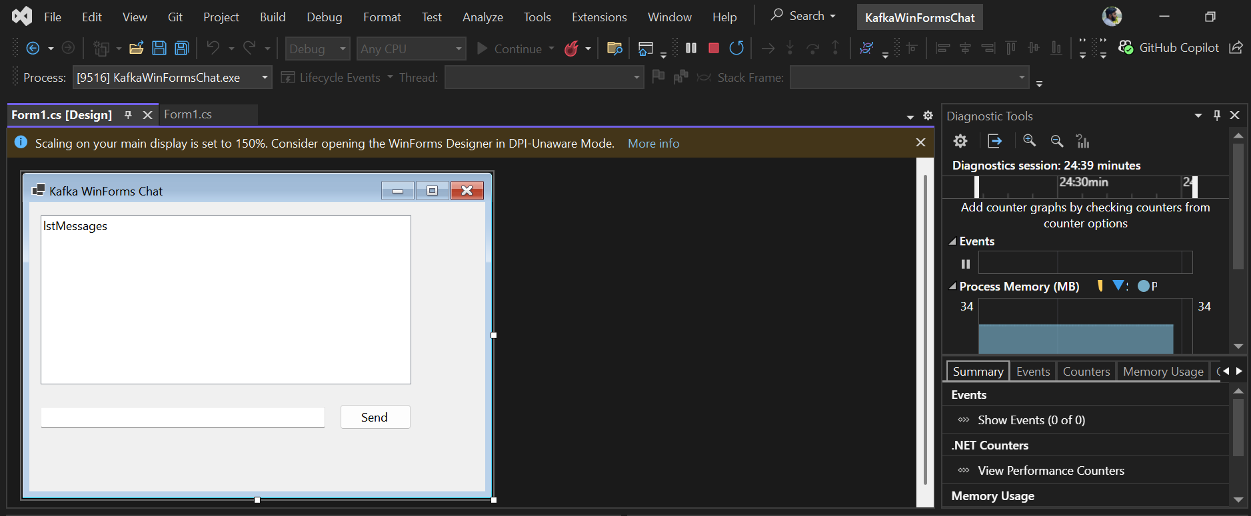

***Now Opening Second Window From File Explorer Where my KafkaWinFormsChat in there open bin then Debug then net8.0 and lastly KafkaWinFormsChat which is exe file by running and opening exe file 2 chat windows open for messaging***

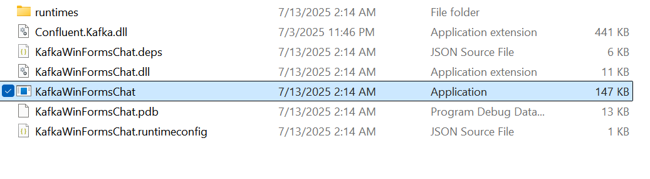

***Now We Have to Test the App By Chatting***

***The First where we type message***

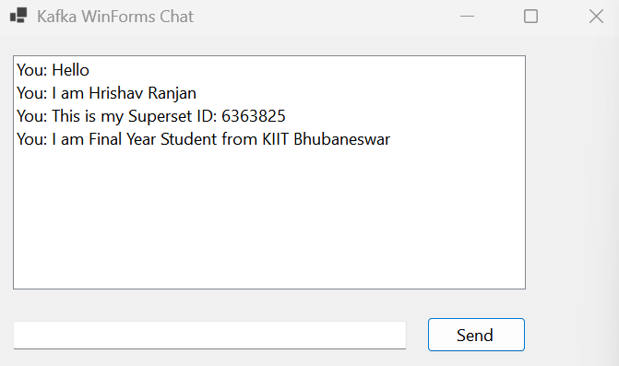

***The second where we receive the message***

